Selenium Environment Setup:
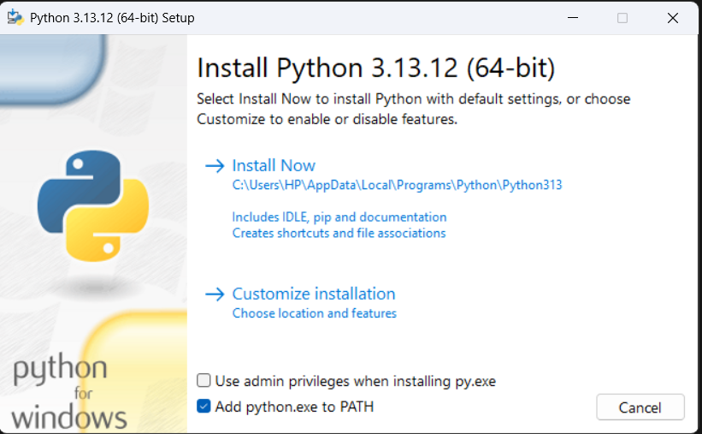
Figure 1: Python 3.13.12 Installation."Add python.exe to PATH" checkbox selected.
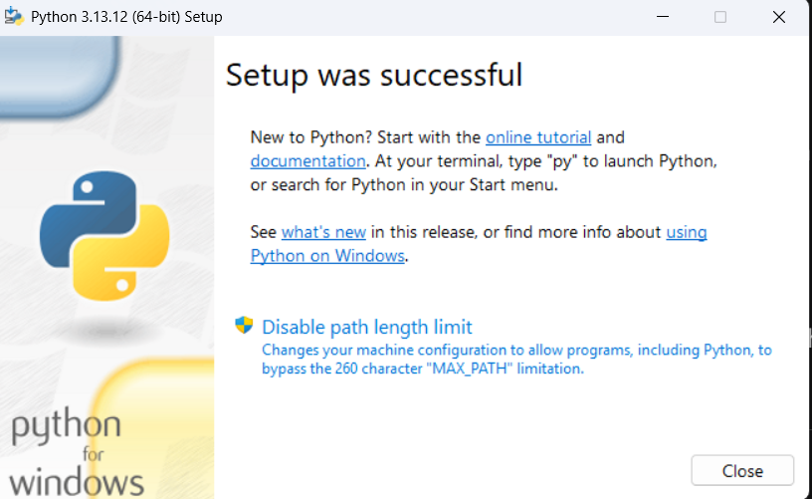
Figure 2: Successful Python Setup.

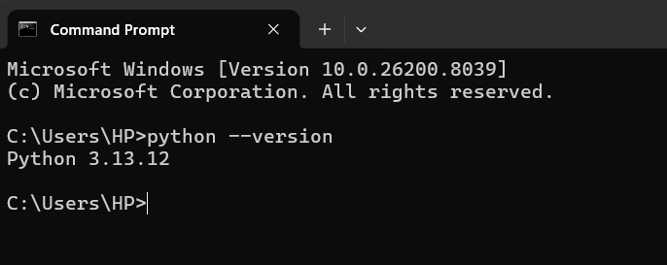
Figure 3: System Path Verification. Command Prompt showing python --version returning 3.13.12.
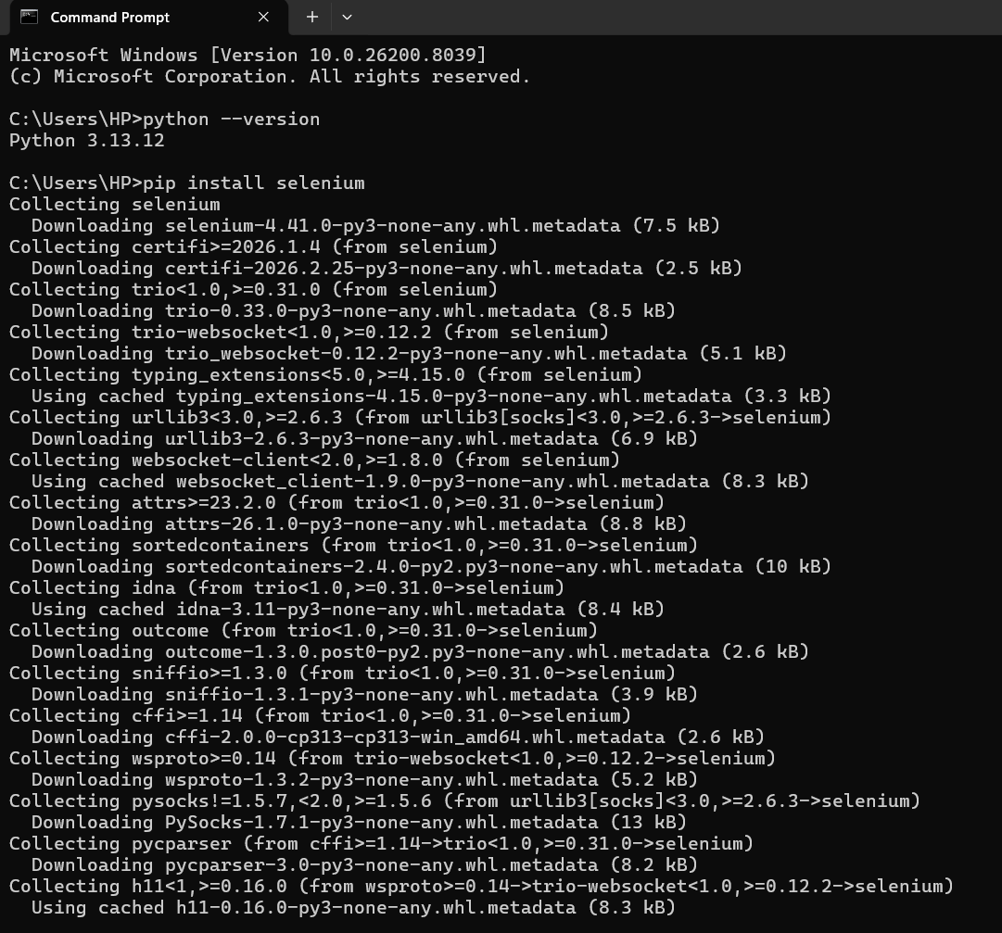
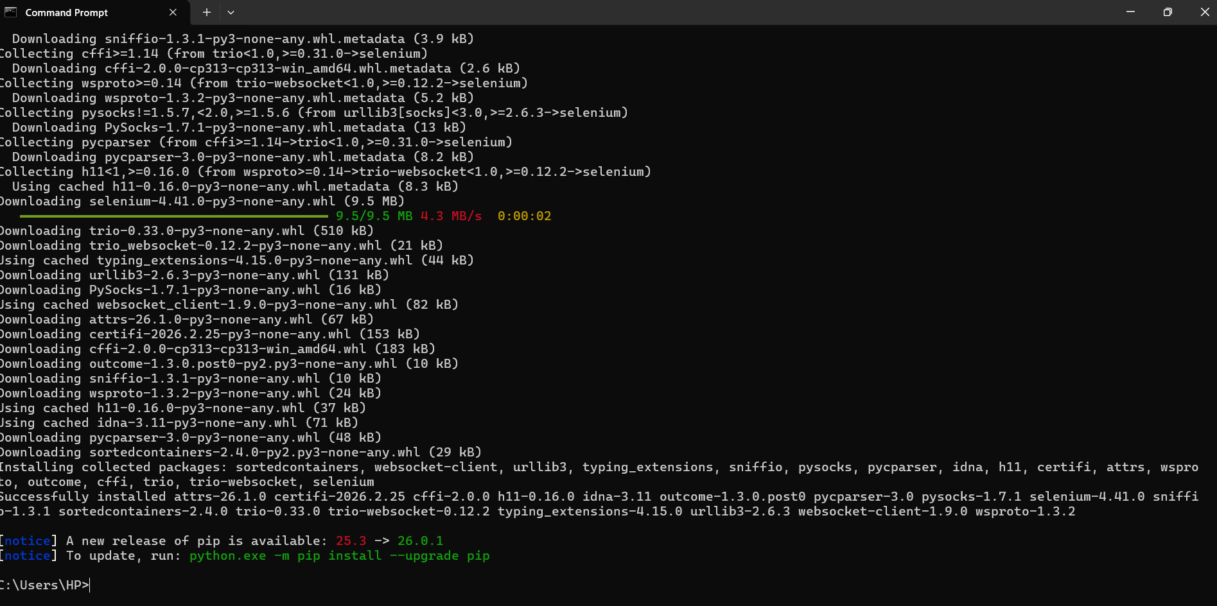
Figure 4: Selenium Library Installation. Command Prompt showing the successful result of
pip install selenium.

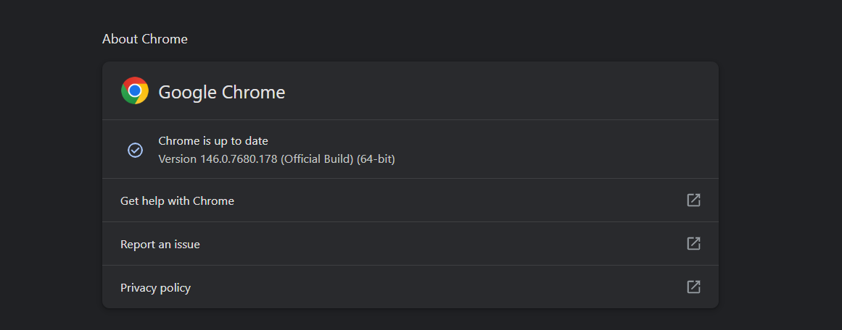
Figure 5: Browser Compatibility (Chrome). Screenshot of "About Chrome" showing version 146.0.7680.178.

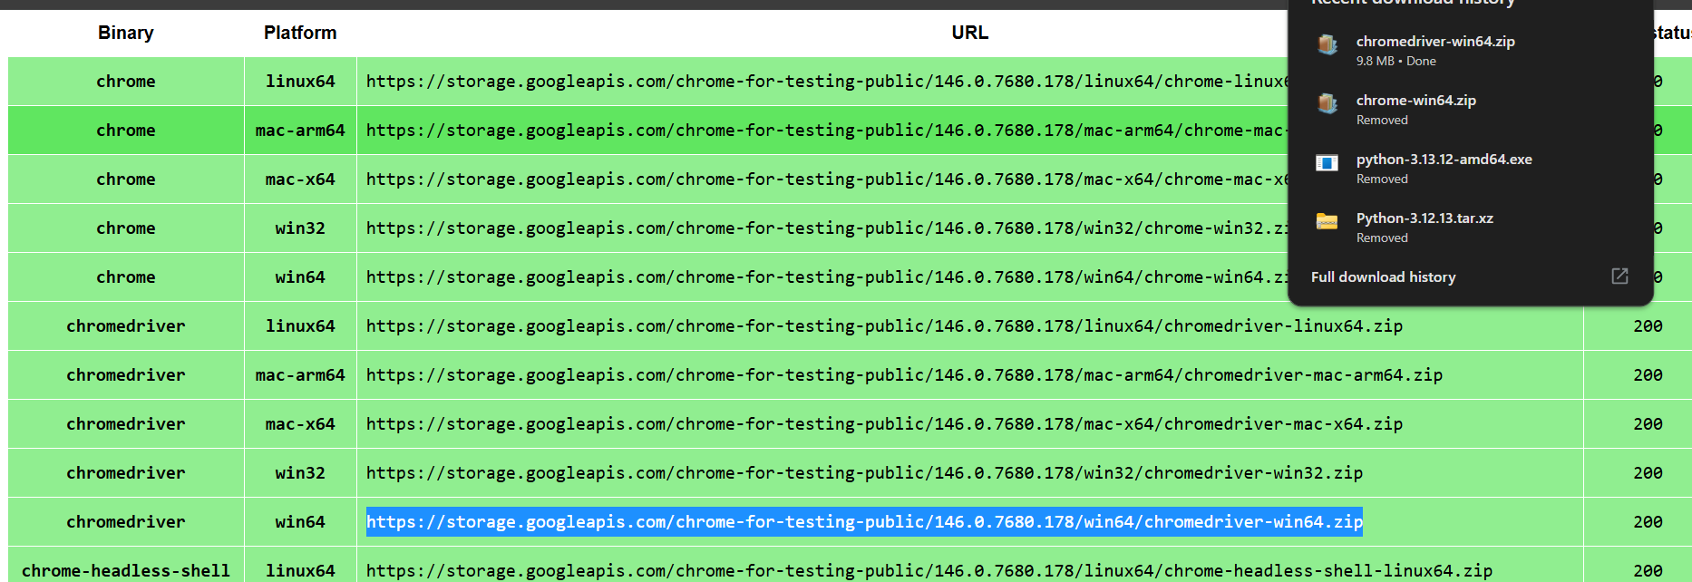
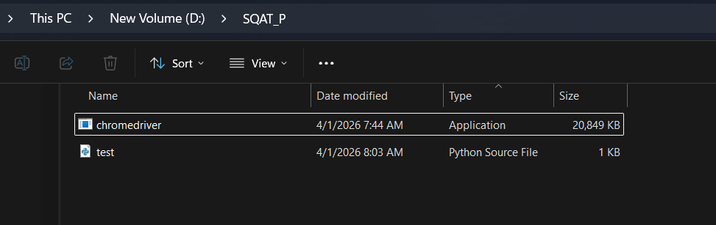
Figure 6: Driver Configuration. Screenshot of the folder D:\SQAT_P containing chromedriver.exe and test scripts.

Connectivity Testing:
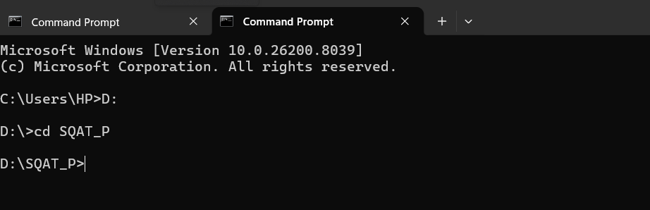
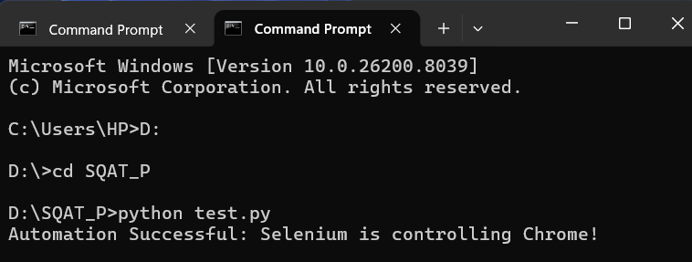
Figure 7: Command Prompt running test.py with the output: "Automation Successful: Selenium is controlling Chrome!"
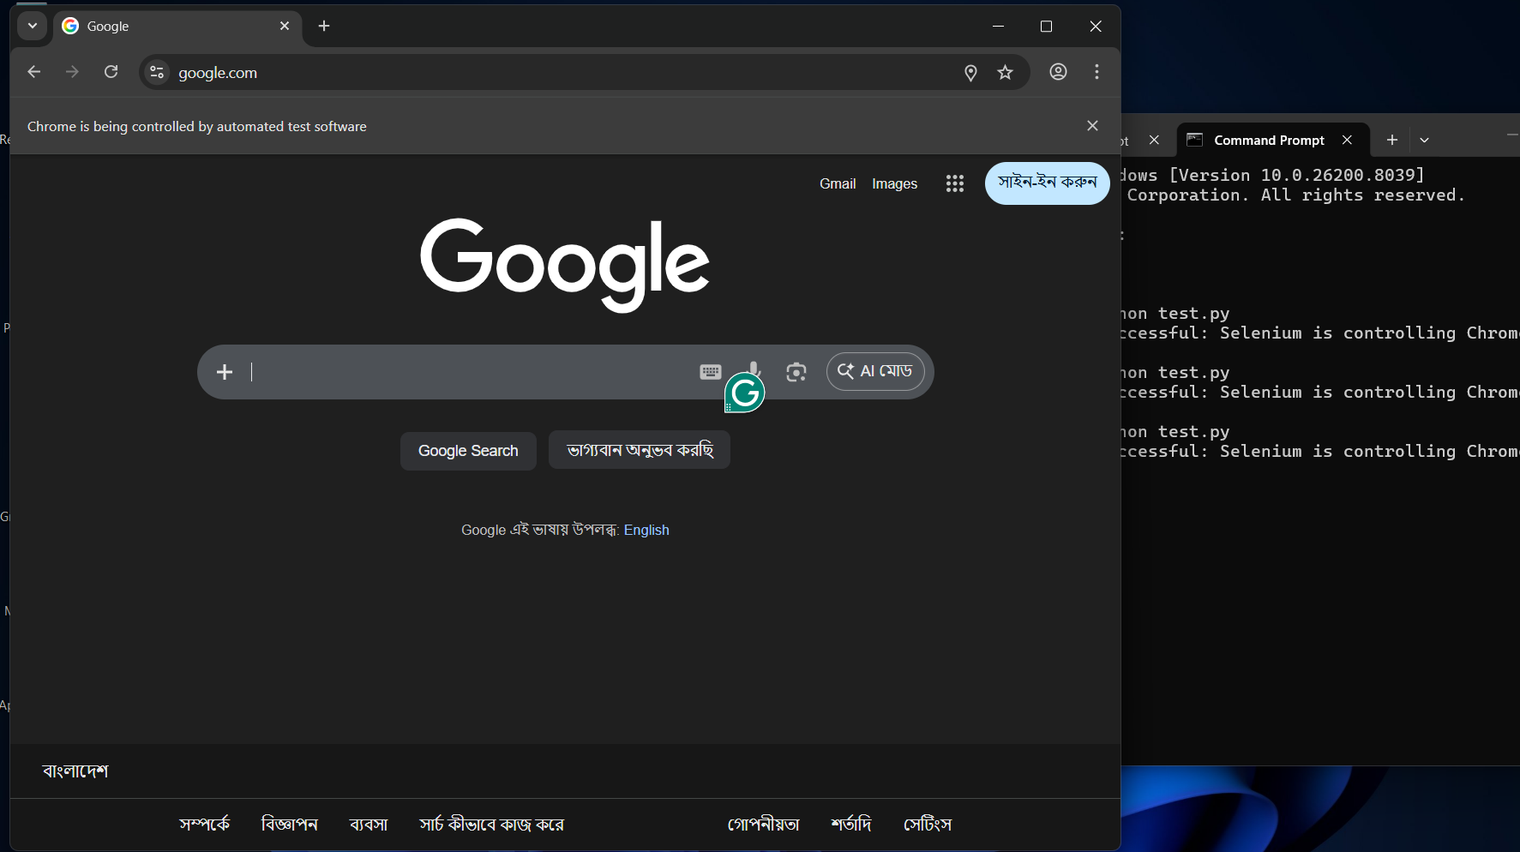
Figure 8: Chrome browser opening google.com with the top bar stating: "Chrome is being controlled by automated test software."

Feature Testing (Hotel Reservation):
Login Feature
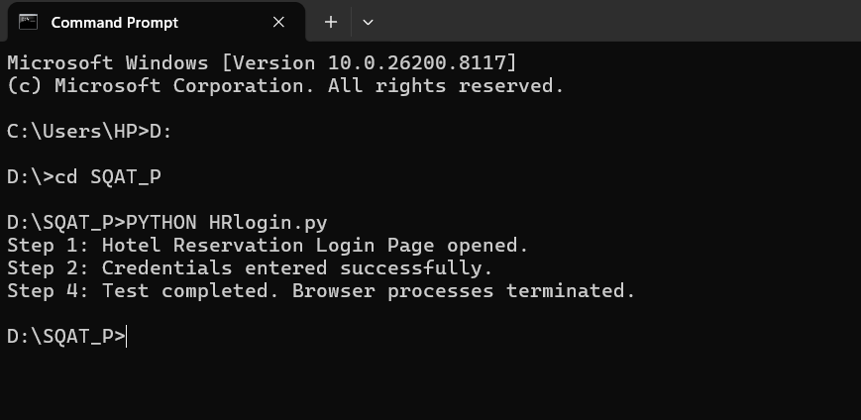
Figure 9: Login Script Execution. Console showing HRlogin.py starting and inputting credentials.
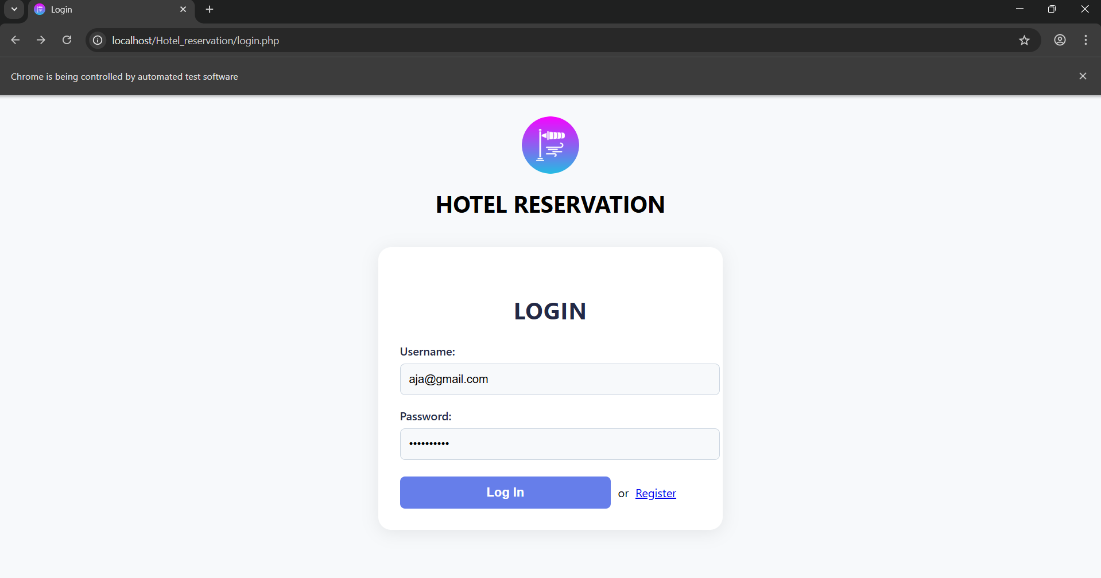
Figure 10: Chrome showing the login fields filled with aja@gmail.com.

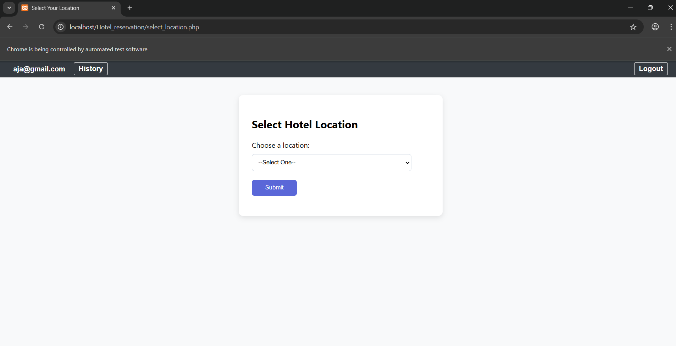
Figure 11: Authentication Success. Successful redirection to select_location.php.

Registration Feature
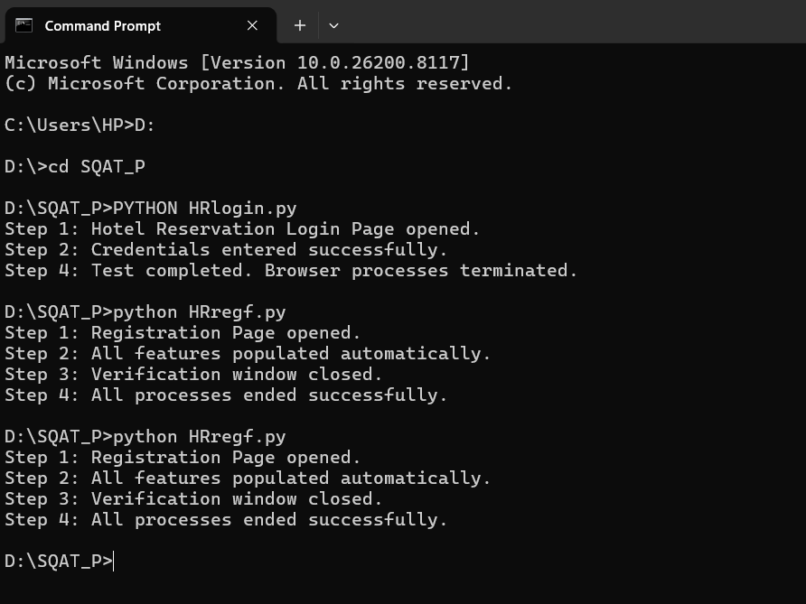
Figure 12: Registration Flow. Command Prompt showing the steps for HRregf.py.

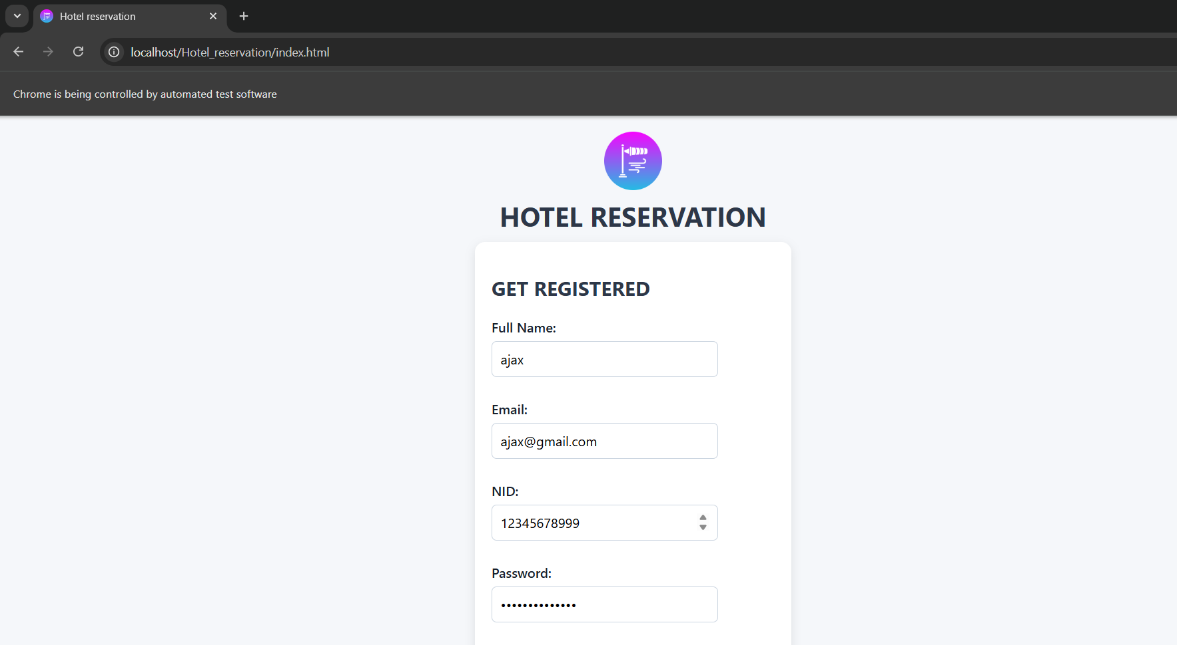
Figure 13: Data Entry Verification. Chrome showing the Full Name, Email, NID, and Gender fields populated by the script.
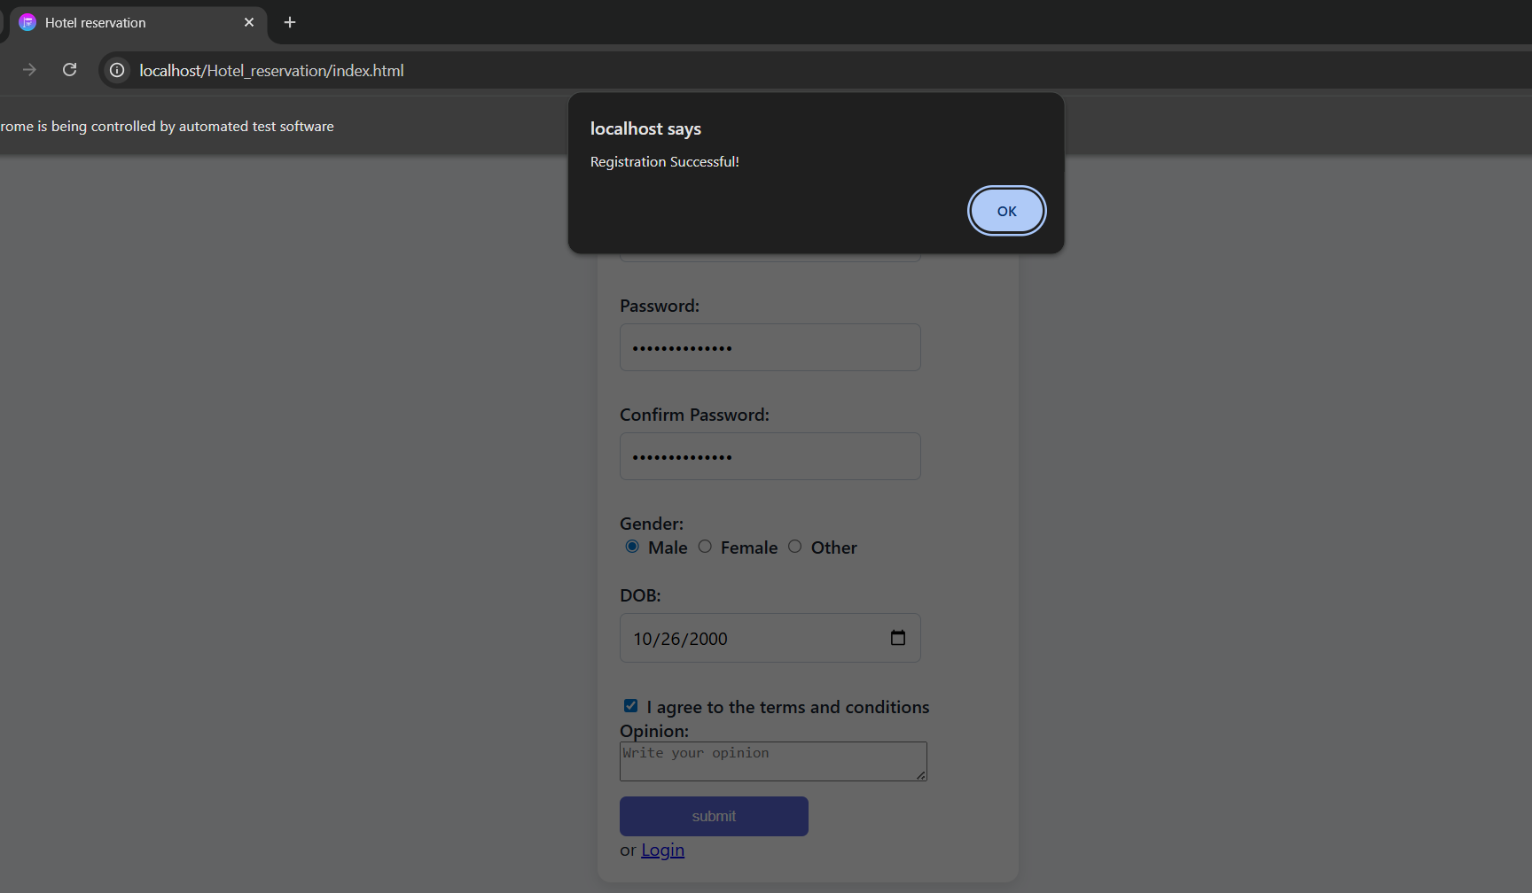
Figure 14: Validation Logic Test. Screenshot of the "Registration Successful!" JavaScript alert box.

Booking Workflow
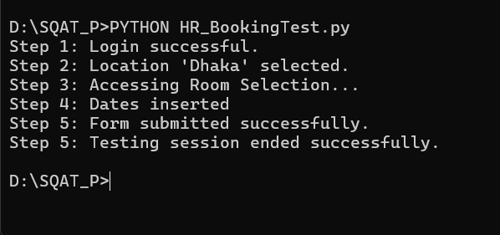
Figure 15: Full Workflow Script. Console log of HR_BookingTest.py performing the multi-page test.

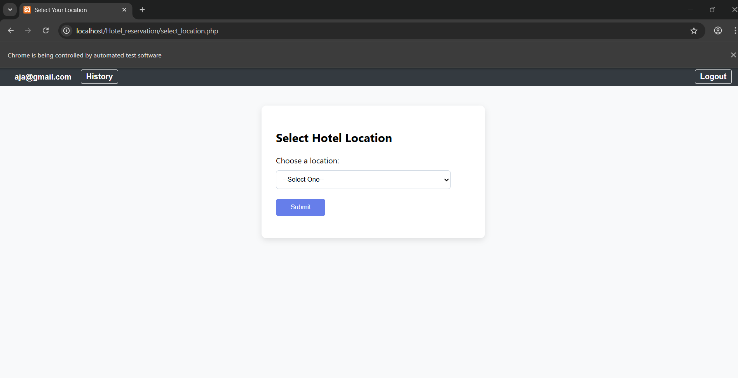

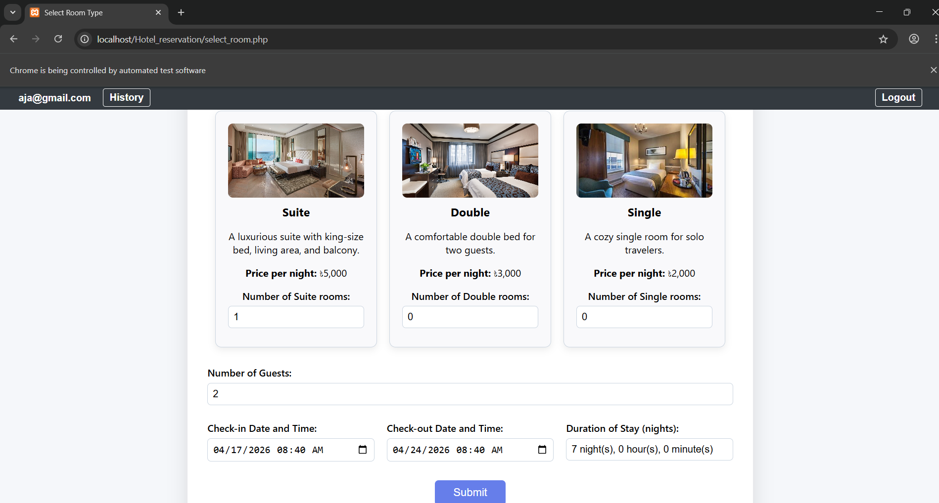
Figure 16: Dynamic Room Selection. Chrome showing 1 Suite room and 2 Guests selected.
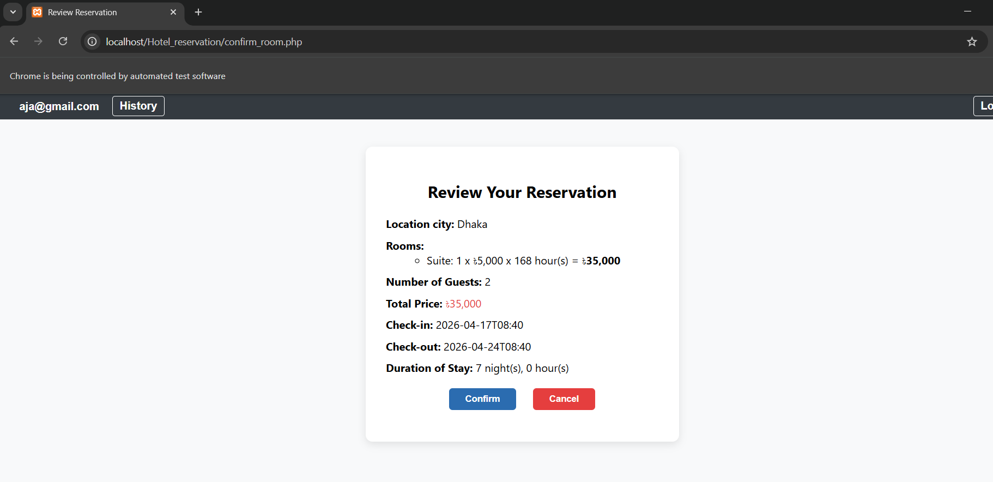
Figure 17: Final Review State. Screenshot of confirm_room.php showing the calculated total for a 7-night stay.

